UNITED STATES
SECURITIES AND EXCHANGE COMMISSION
Washington, D.C. 20549

FORM 8-K

CURRENT REPORT
Pursuant to Section 13 or 15(d) of the
Securities Exchange Act of 1934

Date of Report (Date of earliest event reported): May 27, 2026



BLUEJAY DIAGNOSTICS, INC.
(Exact Name of Registrant as Specified in its Charter)

delaware |  | 001-41031 |  | 47-3552922
(State or Other Jurisdiction of  Incorporation or Organization) |  | (Commission File No.) |  | (I.R.S. Employer  Identification No.)

360 Massachusetts Avenue, Suite 203
Acton, MA 01720
(Address of principal executive offices and zip code)

(844) 327-7078
(Registrant’s telephone number, including area code)

(Former name or former address, if changed from last report)

Check the appropriate box below if the Form 8-K filing is intended to simultaneously satisfy the filing obligation of the registrant under any of the following provisions (see General Instruction A.2. below):

☐ | Written communications pursuant to Rule 425 under the Securities Act (17 CFR 230.425)
☐ | Soliciting material pursuant to Rule 14a-12 under the Exchange Act (17 CFR 240.14a-12)
☐ | Pre-commencement communications pursuant to Rule 14d-2(b) under the Exchange Act (17 CFR 240.14d-2(b))
☐ | Pre-commencement communications pursuant to Rule 13e-4(c) under the Exchange Act (17 CFR 240.13e-14(c))

Indicate by check mark whether the registrant is an emerging growth company as defined in Rule 405 of the Securities Act of 1933 (§230.405 of this chapter) or Rule 12b-2 of the Securities Exchange Act of 1934 (§240.12b-2 of this chapter).

Emerging growth company ☒

If an emerging growth company, indicate by check mark if the registrant has elected not to use the extended transition period for complying with any new or revised financial accounting standards provided pursuant to Section 13(a) of the Exchange Act. ☐

Securities registered pursuant to Section 12(b) of the Act:

Title of each class |  | Trading Symbol (s) |  | Name of each exchange on which registered
Common Stock, par value $0.0001 per share |  | BJDX |  | The Nasdaq Stock Market LLC

Item 1.01 Entry into a Material Definitive Agreement.

On May 27, 2026, Bluejay Diagnostics, Inc. (the “Company”) entered into an agreement and statement of work (together, the “Agreement”) with Argonaut Manufacturing Services c/o Argonaut, Inc. (“Argonaut”) regarding the provision by Argonaut to the Company of certain manufacturing services to support the Company’s Symphony™ platform. The services include planning, engineering, sourcing, supply chain management, formulation, filling, finishing, quality control testing, procurement of capital equipment and product storage, delivery and distribution relating to the Company’s IL-6 testing products. All services under the Agreement are to be performed pursuant to terms contained in purchase orders to be provided by the Company to Argonaut from time-to-time.

The foregoing description of the Agreement does not purport to be complete and is qualified in its entirety by reference to the full text of such agreement, which is filed as Exhibit 10.1 to this Current Report on Form 8-K and is incorporated herein by reference.

Item 7.01 Regulation FD Disclosure.

On June 2, 2026, the Company issued a press release in connection with the matters discussed herein under item 1.01. A copy of that press release is furnished with this report as Exhibit 99.1.

The information contained in Item 7.01 of this Current Report on Form 8-K, including Exhibit 99.1, is being furnished and shall not be “filed” for the purpose of the Securities Exchange Act of 1934, as amended, nor shall it be incorporated by reference in any filing under the Exchange Act or the Securities Act of 1933, as amended, unless specifically identified therein as being incorporated by reference.

Item 9.01. Financial Statements and Exhibits.

(d) Exhibits

10.1 |  | Agreement dated May 27, 2026, between Bluejay Diagnostics, Inc. and Argonaut Manufacturing Services
99.1 |  | Press Release, dated June 2, 2026.
104 |  | Cover Page Interactive Data File (embedded within the Inline XBRL document).

1

SIGNATURES

Pursuant to the requirements of the Securities Exchange Act of 1934, the registrant has duly caused this report to be signed on its behalf by the undersigned, hereunto duly authorized.

 | Bluejay Diagnostics, Inc.
 | By: | /s/ Neil Dey
 |  | Neil Dey
 |  | President and Chief Executive Officer

Date: June 2, 2026

2

Exhibit 10.1

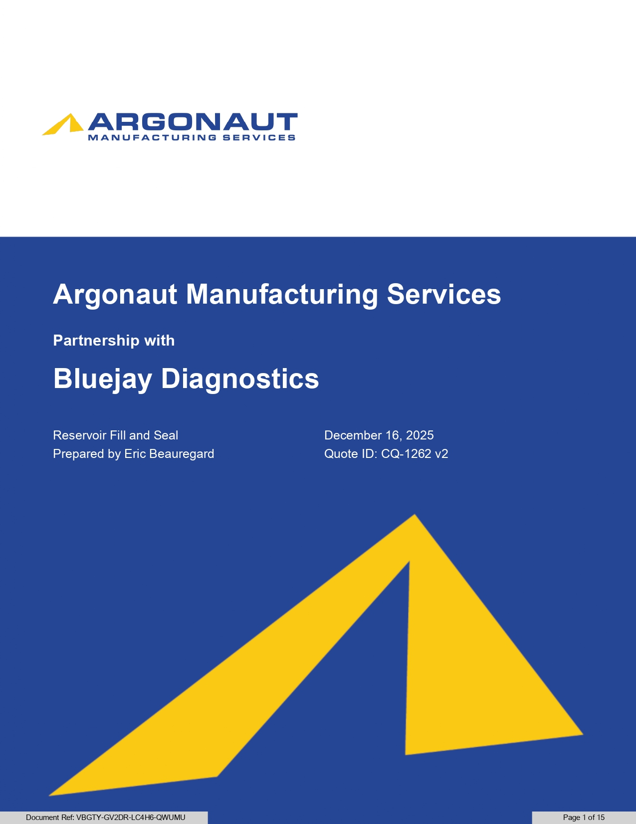
Argonaut Manufacturing Services Partnership with Bluejay Diagnostics Reservoir Fill and Seal Prepared by Eric Beauregard December 16, 2025 Quote ID: CQ - 1262 v2 Document Ref: VBGTY - GV2DR - LC4H6 - QWUMU Page 1 of 15

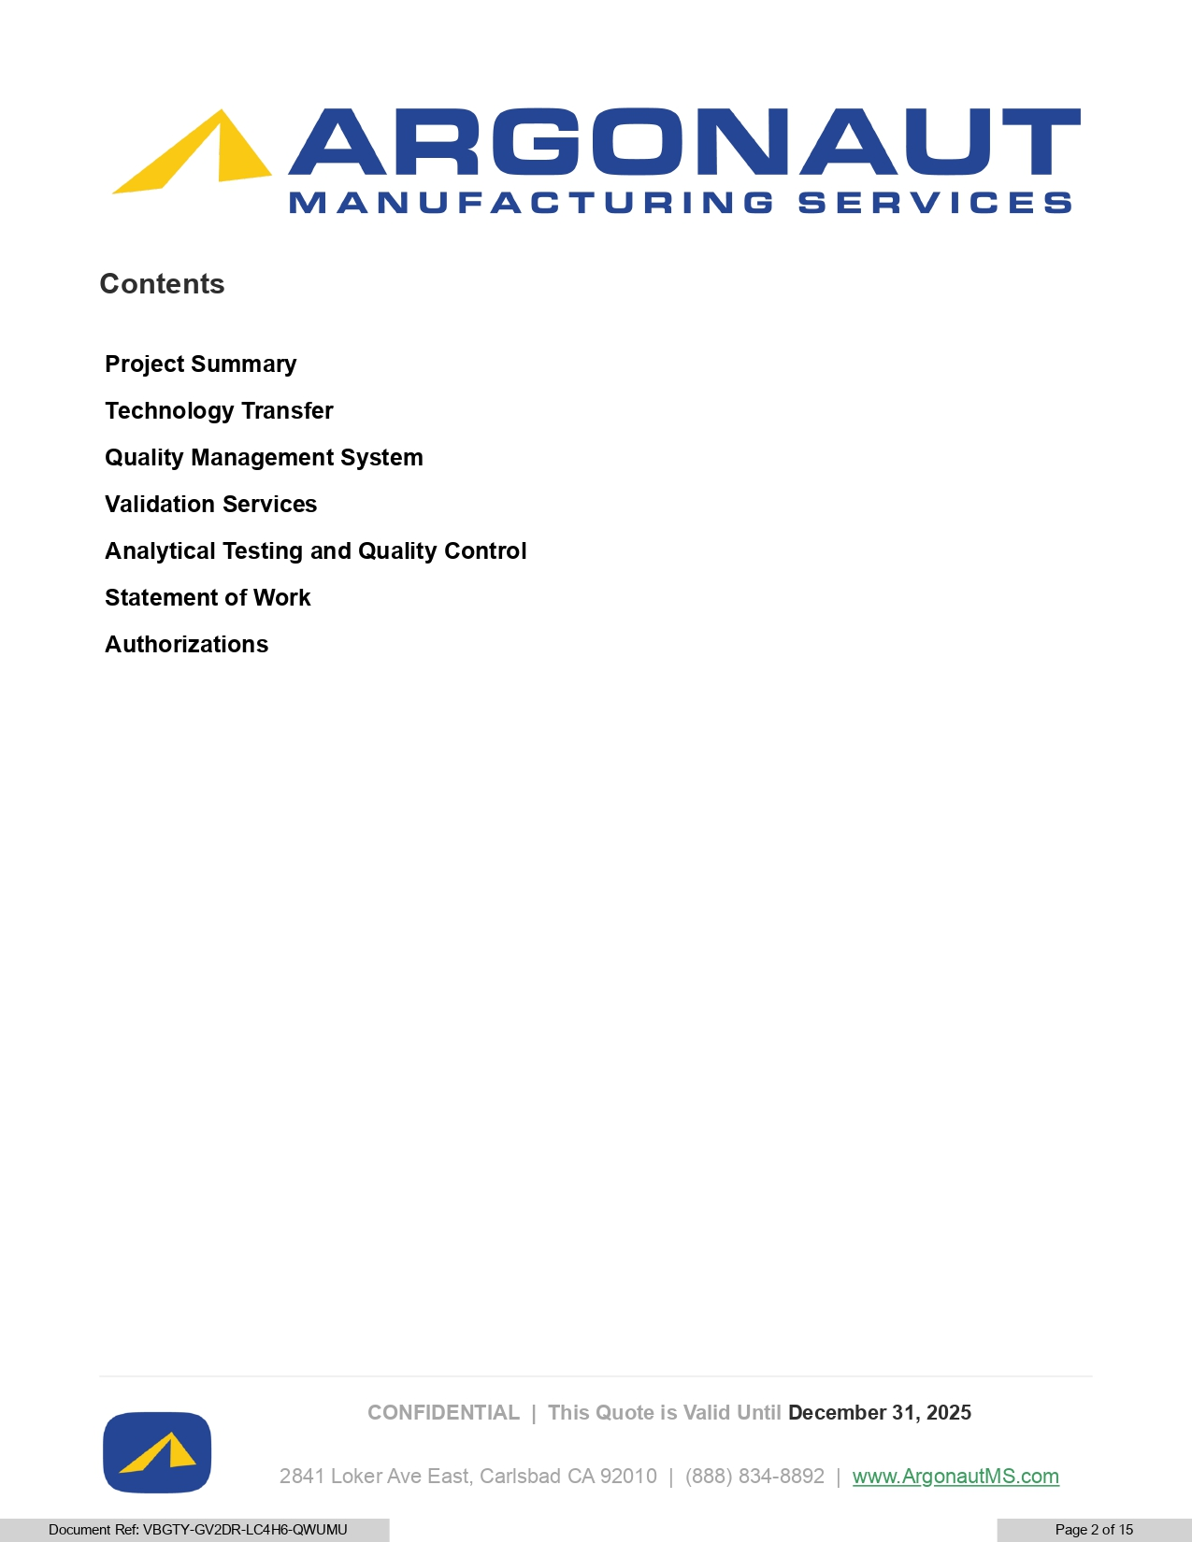
CONFIDENTIAL | This Quote is Valid Until December 31, 2025 Contents Project Summary Technology Transfer Quality Management System Validation Services Analytical Testing and Quality Control Statement of Work Authorizations 2841 Loker Ave East, Carlsbad CA 92010 | (888) 834 - 8892 | www.A rg onautMS.com Document Ref: VBGTY - GV2DR - LC4H6 - QWUMU Page 2 of 15

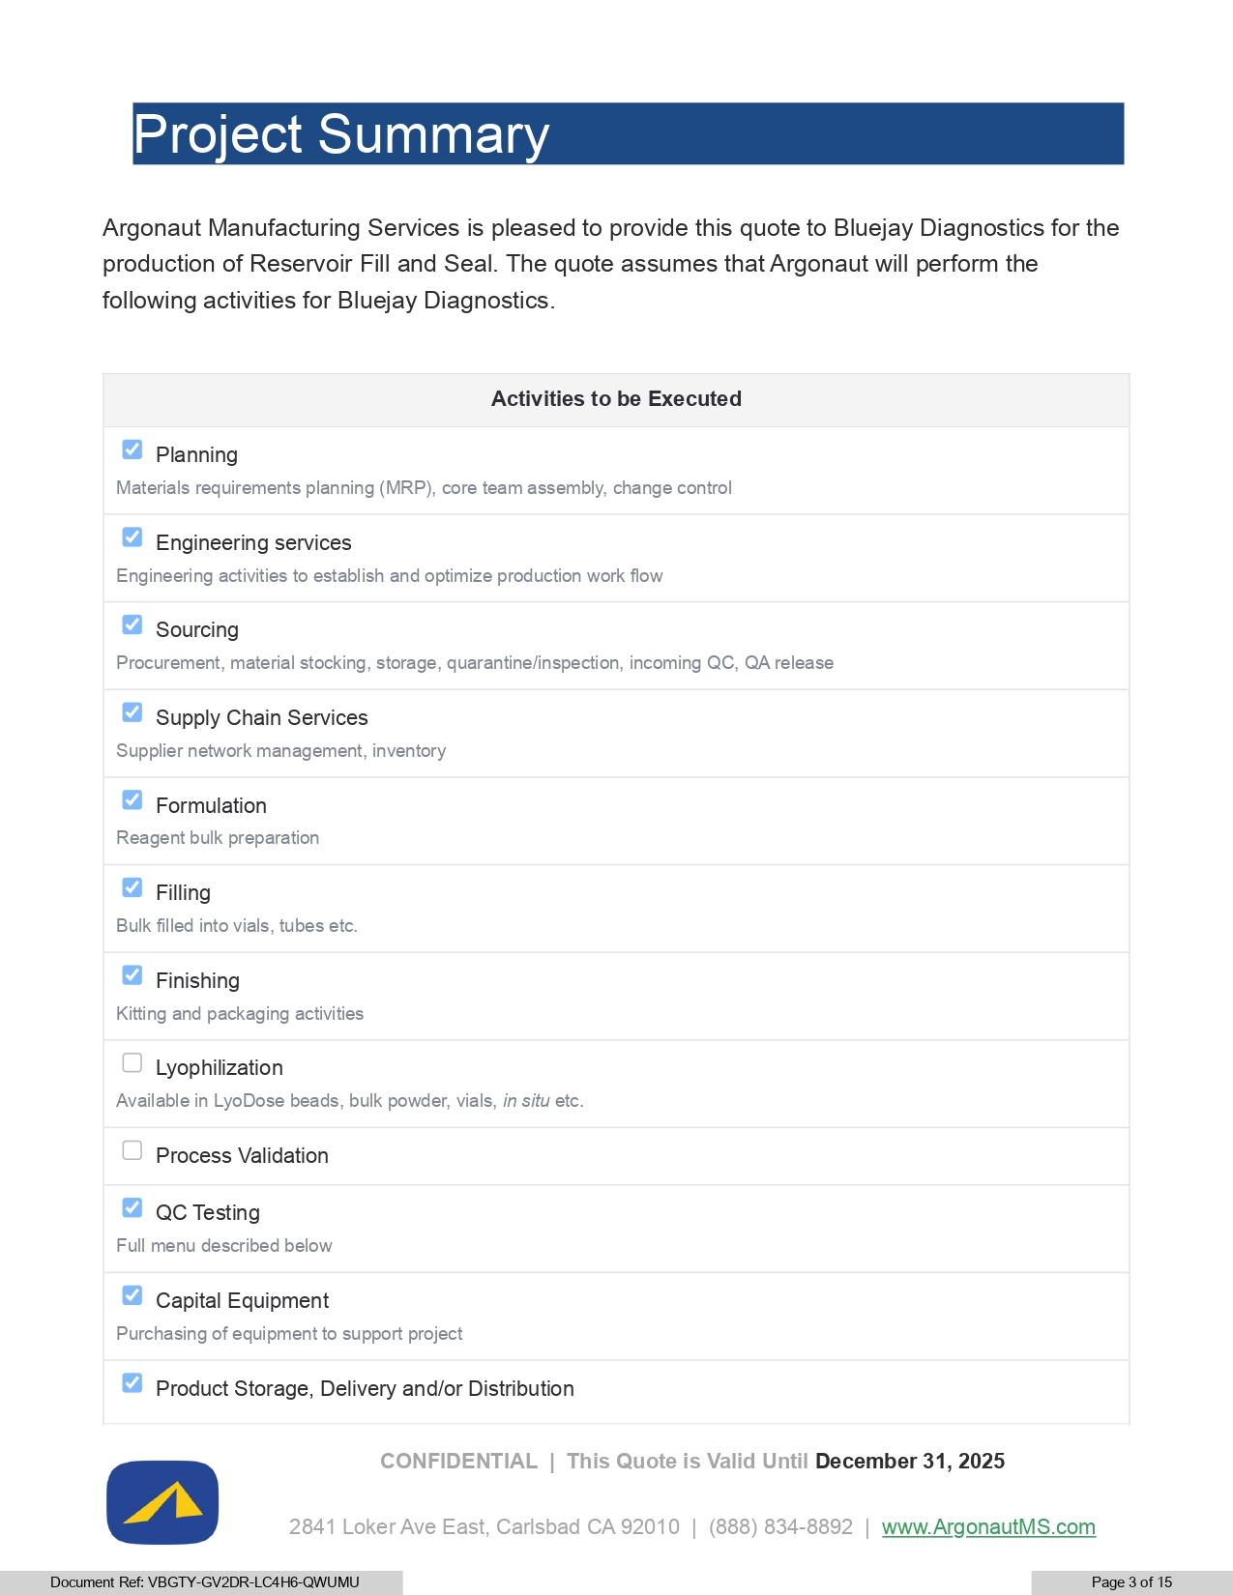
Activities to be Executed Planning Materials requirements planning (MRP), core team assembly, change control Engineering services Engineering activities to establish and optimize production work flow Sourcing Procurement, material stocking, storage, quarantine/inspection, incoming QC, QA release Supply Chain Services Supplier network management, inventory Formulation Reagent bulk preparation Filling Bulk filled into vials, tubes etc. Finishing Kitting and packaging activities Lyophilization Available in LyoDose beads, bulk powder, vials, in situ etc. Process Validation QC Testing Full menu described below Capital Equipment Purchasing of equipment to support project Product Storage, Delivery and/or Distribution CONFIDENTIAL | This Quote is Valid Until December 31, 2025 Project Summary Argonaut Manufacturing Services is pleased to provide this quote to Bluejay Diagnostics for the production of Reservoir Fill and Seal. The quote assumes that Argonaut will perform the following activities for Bluejay Diagnostics. 2841 Loker Ave East, Carlsbad CA 92010 | (888) 834 - 8892 | www.A rg onautMS.com Document Ref: VBGTY - GV2DR - LC4H6 - QWUMU Page 3 of 15

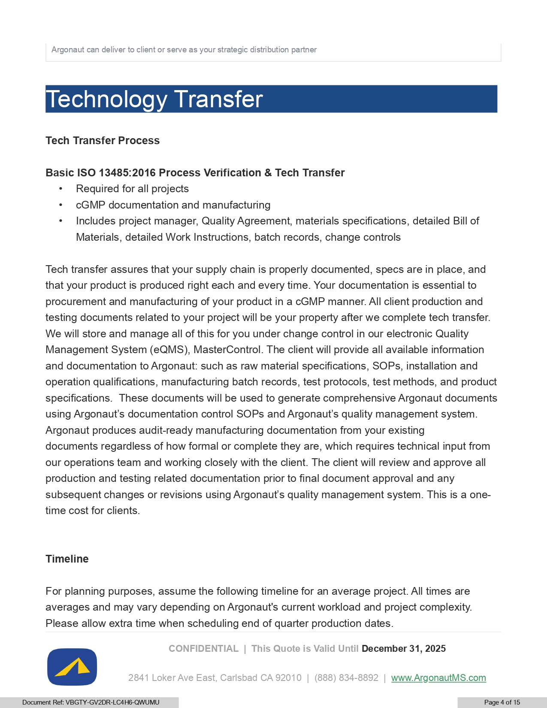
Timeline For planning purposes, assume the following timeline for an average project . All times are averages and may vary depending on Argonaut's current workload and project complexity . Please allow extra time when scheduling end of quarter production dates . CONFIDENTIAL | This Quote is Valid Until December 31, 2025 Argonaut can deliver to client or serve as your strategic distribution partner Technology Transfer Tech Transfer Process Basic ISO 13485:2016 Process Verification & Tech Transfer • Required for all projects • cGMP documentation and manufacturing • Includes project manager, Quality Agreement, materials specifications, detailed Bill of Materials, detailed Work Instructions, batch records, change controls Tech transfer assures that your supply chain is properly documented, specs are in place, and that your product is produced right each and every time. Your documentation is essential to procurement and manufacturing of your product in a cGMP manner. All client production and testing documents related to your project will be your property after we complete tech transfer. We will store and manage all of this for you under change control in our electronic Quality Management System (eQMS), MasterControl. The client will provide all available information and documentation to Argonaut: such as raw material specifications, SOPs, installation and operation qualifications, manufacturing batch records, test protocols, test methods, and product specifications. These documents will be used to generate comprehensive Argonaut documents using Argonaut’s documentation control SOPs and Argonaut’s quality management system. Argonaut produces audit - ready manufacturing documentation from your existing documents regardless of how formal or complete they are, which requires technical input from our operations team and working closely with the client. The client will review and approve all production and testing related documentation prior to final document approval and any subsequent changes or revisions using Argonaut’s quality management system. This is a one - time cost for clients. 2841 Loker Ave East, Carlsbad CA 92010 | (888) 834 - 8892 | www.A rg onautMS.com Document Ref: VBGTY - GV2DR - LC4H6 - QWUMU Page 4 of 15

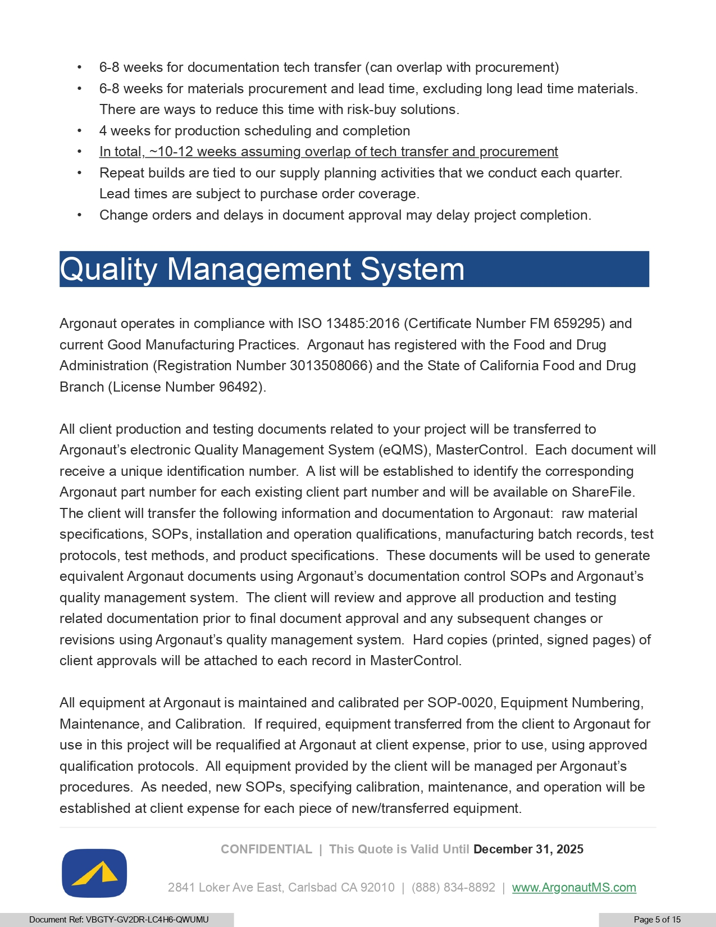
Argonaut operates in compliance with ISO 13485:2016 (Certificate Number FM 659295) and current Good Manufacturing Practices. Argonaut has registered with the Food and Drug Administration (Registration Number 3013508066) and the State of California Food and Drug Branch (License Number 96492). All client production and testing documents related to your project will be transferred to Argonaut’s electronic Quality Management System (eQMS), MasterControl. Each document will receive a unique identification number. A list will be established to identify the corresponding Argonaut part number for each existing client part number and will be available on ShareFile. The client will transfer the following information and documentation to Argonaut: raw material specifications, SOPs, installation and operation qualifications, manufacturing batch records, test protocols, test methods, and product specifications. These documents will be used to generate equivalent Argonaut documents using Argonaut’s documentation control SOPs and Argonaut’s quality management system. The client will review and approve all production and testing related documentation prior to final document approval and any subsequent changes or revisions using Argonaut’s quality management system. Hard copies (printed, signed pages) of client approvals will be attached to each record in MasterControl. All equipment at Argonaut is maintained and calibrated per SOP - 0020, Equipment Numbering, Maintenance, and Calibration. If required, equipment transferred from the client to Argonaut for use in this project will be requalified at Argonaut at client expense, prior to use, using approved qualification protocols. All equipment provided by the client will be managed per Argonaut’s procedures. As needed, new SOPs, specifying calibration, maintenance, and operation will be established at client expense for each piece of new/transferred equipment. CONFIDENTIAL | This Quote is Valid Until December 31, 2025 • 6 - 8 weeks for documentation tech transfer (can overlap with procurement) • 6 - 8 weeks for materials procurement and lead time, excluding long lead time materials. There are ways to reduce this time with risk - buy solutions. • 4 weeks for production scheduling and completion • In total , ~10 - 12 weeks assuming overlap of tech transfer and procurement • Repeat builds are tied to our supply planning activities that we conduct each quarter. Lead times are subject to purchase order coverage. • Change orders and delays in document approval may delay project completion. Quality Management System 2841 Loker Ave East, Carlsbad CA 92010 | (888) 834 - 8892 | www.A rg onautMS.com Document Ref: VBGTY - GV2DR - LC4H6 - QWUMU Page 5 of 15

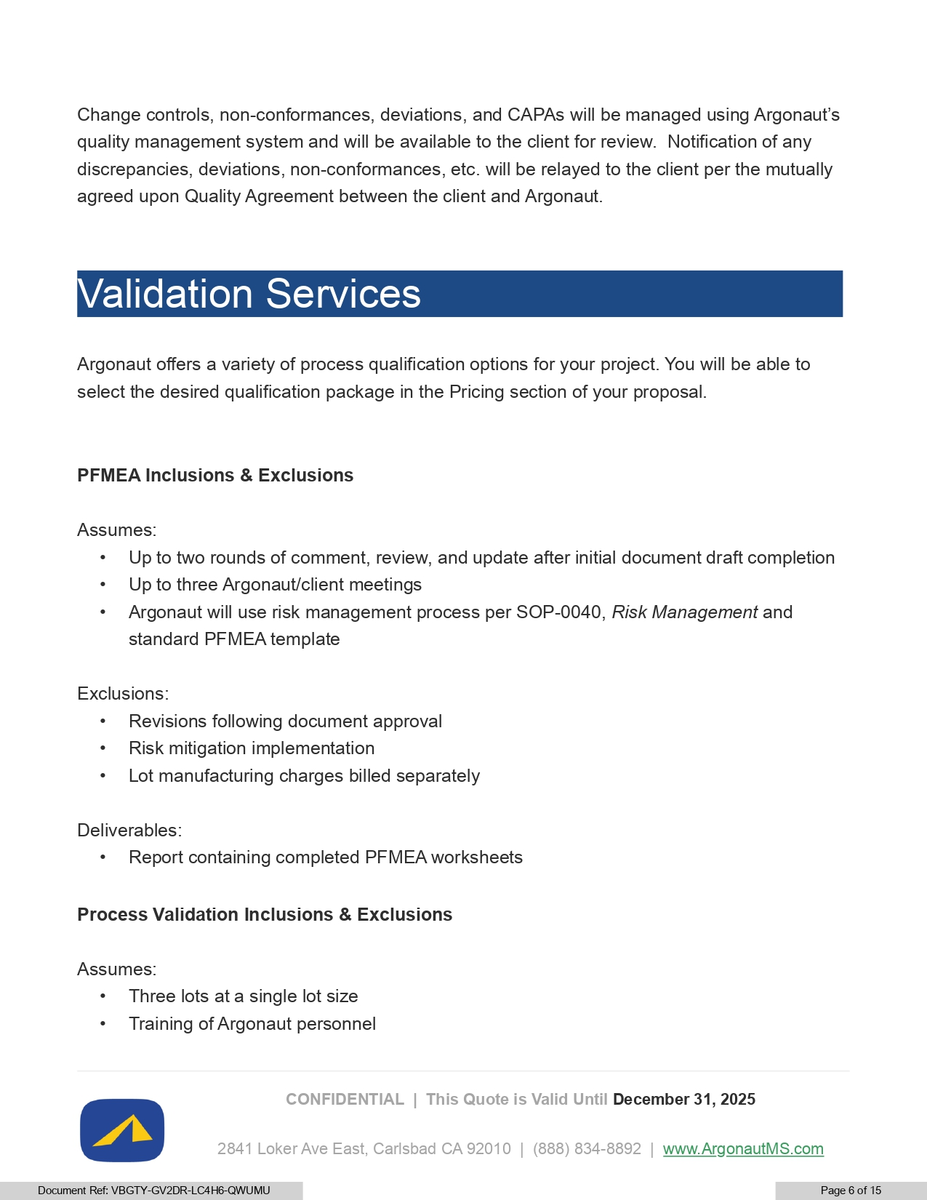
CONFIDENTIAL | This Quote is Valid Until December 31, 2025 Change controls, non - conformances, deviations, and CAPAs will be managed using Argonaut’s quality management system and will be available to the client for review. Notification of any discrepancies, deviations, non - conformances, etc. will be relayed to the client per the mutually agreed upon Quality Agreement between the client and Argonaut. Validation Services Argonaut offers a variety of process qualification options for your project. You will be able to select the desired qualification package in the Pricing section of your proposal. PFMEA Inclusions & Exclusions Assumes: • Up to two rounds of comment, review, and update after initial document draft completion • Up to three Argonaut/client meetings • Argonaut will use risk management process per SOP - 0040, Risk Management and standard PFMEA template Exclusions: • Revisions following document approval • Risk mitigation implementation • Lot manufacturing charges billed separately Deliverables: • Report containing completed PFMEA worksheets Process Validation Inclusions & Exclusions Assumes: • Three lots at a single lot size • Training of Argonaut personnel 2841 Loker Ave East, Carlsbad CA 92010 | (888) 834 - 8892 | www.A rg onautMS.com Document Ref: VBGTY - GV2DR - LC4H6 - QWUMU Page 6 of 15

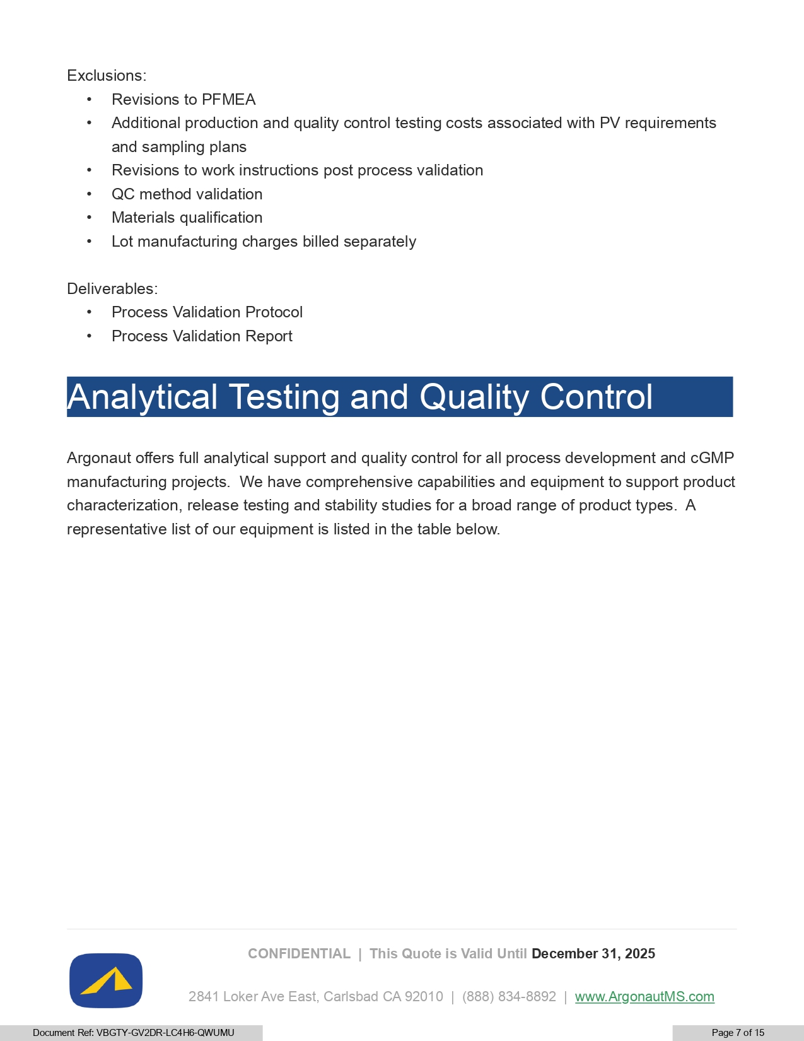
CONFIDENTIAL | This Quote is Valid Until December 31, 2025 Exclusions: • Revisions to PFMEA • Additional production and quality control testing costs associated with PV requirements and sampling plans • Revisions to work instructions post process validation • QC method validation • Materials qualification • Lot manufacturing charges billed separately Deliverables: • Process Validation Protocol • Process Validation Report Analytical Testing and Quality Control Argonaut offers full analytical support and quality control for all process development and cGMP manufacturing projects. We have comprehensive capabilities and equipment to support product characterization, release testing and stability studies for a broad range of product types. A representative list of our equipment is listed in the table below. 2841 Loker Ave East, Carlsbad CA 92010 | (888) 834 - 8892 | www.A rg onautMS.com Document Ref: VBGTY - GV2DR - LC4H6 - QWUMU Page 7 of 15

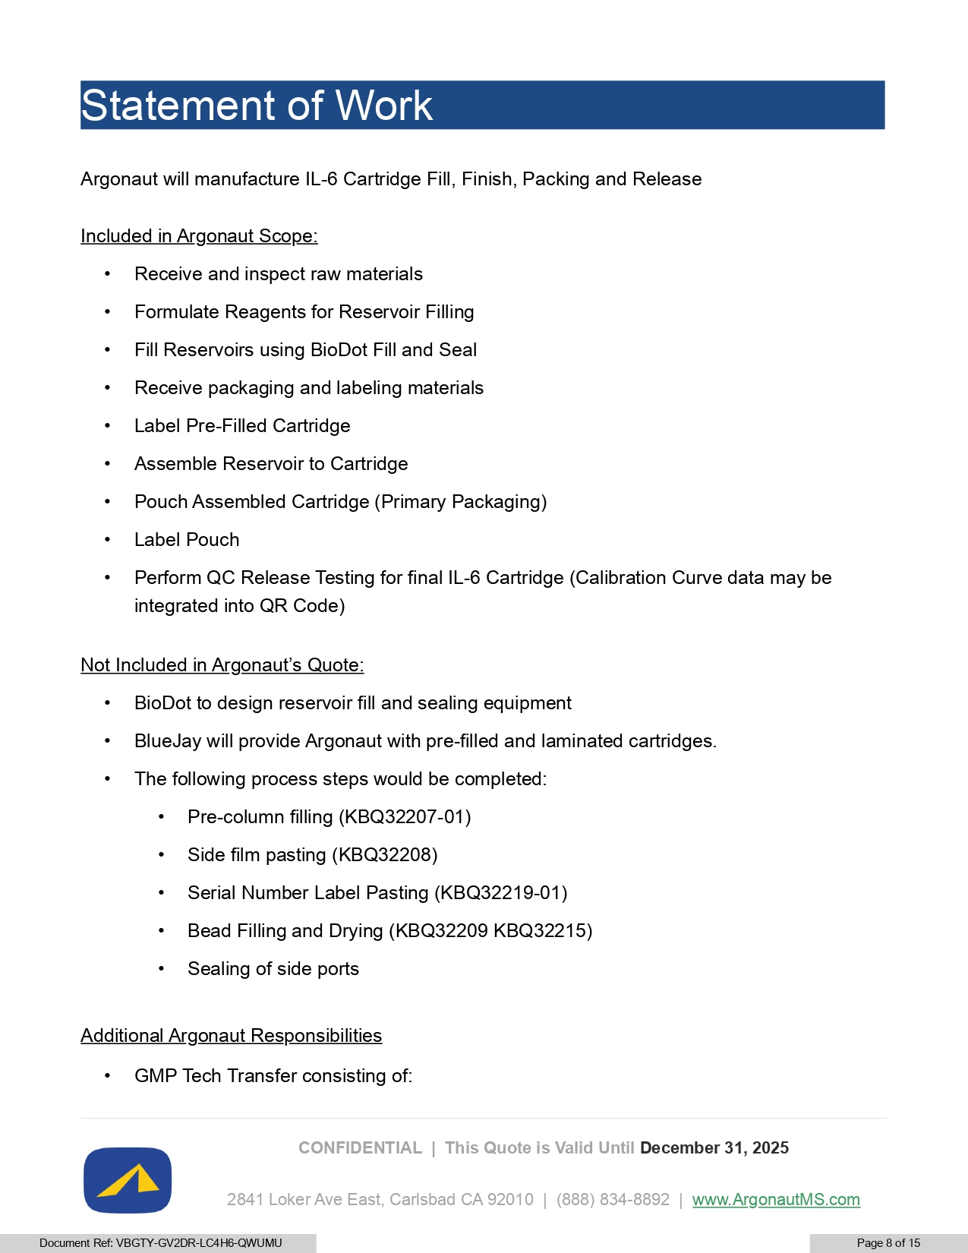
CONFIDENTIAL | This Quote is Valid Until December 31, 2025 Statement of Work Argonaut will manufacture IL - 6 Cartridge Fill, Finish, Packing and Release Included in Argonaut Scope: • Receive and inspect raw materials • Formulate Reagents for Reservoir Filling • Fill Reservoirs using BioDot Fill and Seal • Receive packaging and labeling materials • Label Pre - Filled Cartridge • Assemble Reservoir to Cartridge • Pouch Assembled Cartridge (Primary Packaging) • Label Pouch • Perform QC Release Testing for final IL - 6 Cartridge (Calibration Curve data may be integrated into QR Code) Not Included in Argonaut’s Quote: • BioDot to design reservoir fill and sealing equipment • BlueJay will provide Argonaut with pre - filled and laminated cartridges. • The following process steps would be completed: • Pre - column filling (KBQ32207 - 01) • Side film pasting (KBQ32208) • Serial Number Label Pasting (KBQ32219 - 01) • Bead Filling and Drying (KBQ32209 KBQ32215) • Sealing of side ports Additional Argonaut Responsibilities • GMP Tech Transfer consisting of: 2841 Loker Ave East, Carlsbad CA 92010 | (888) 834 - 8892 | www.A rg onautMS.com Document Ref: VBGTY - GV2DR - LC4H6 - QWUMU Page 8 of 15

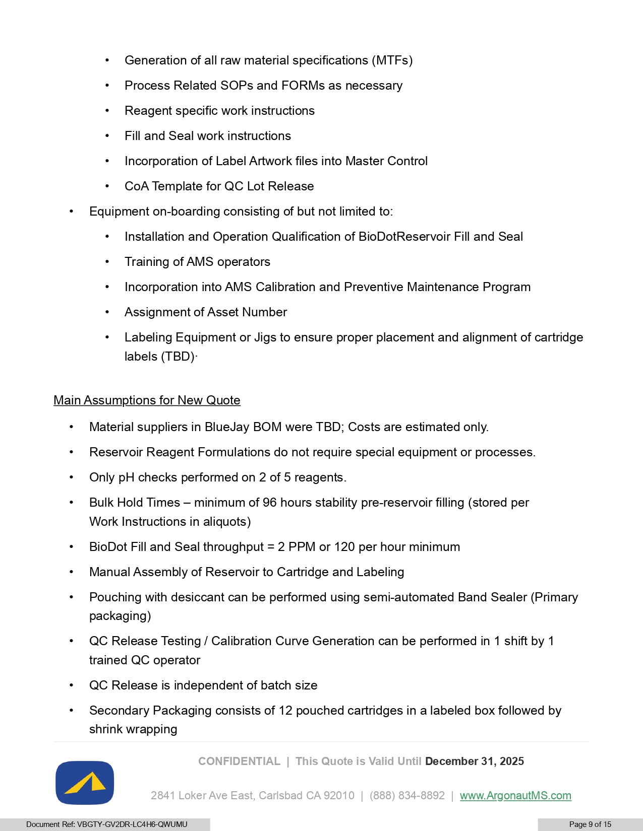
• Generation of all raw material specifications (MTFs) • Process Related SOPs and FORMs as necessary • Reagent specific work instructions • Fill and Seal work instructions • Incorporation of Label Artwork files into Master Control • CoA Template for QC Lot Release • Equipment on - boarding consisting of but not limited to: • Installation and Operation Qualification of BioDotReservoir Fill and Seal • Training of AMS operators • Incorporation into AMS Calibration and Preventive Maintenance Program • Assignment of Asset Number • Labeling Equipment or Jigs to ensure proper placement and alignment of cartridge labels (TBD)· Main Assumptions for New Quote • Material suppliers in BlueJay BOM were TBD; Costs are estimated only. • Reservoir Reagent Formulations do not require special equipment or processes. • Only pH checks performed on 2 of 5 reagents. • Bulk Hold Times – minimum of 96 hours stability pre - reservoir filling (stored per Work Instructions in aliquots) • BioDot Fill and Seal throughput = 2 PPM or 120 per hour minimum • Manual Assembly of Reservoir to Cartridge and Labeling • Pouching with desiccant can be performed using semi - automated Band Sealer (Primary packaging) • QC Release Testing / Calibration Curve Generation can be performed in 1 shift by 1 trained QC operator • QC Release is independent of batch size • Secondary Packaging consists of 12 pouched cartridges in a labeled box followed by shrink wrapping CONFIDENTIAL | This Quote is Valid Until December 31, 2025 2841 Loker Ave East, Carlsbad CA 92010 | (888) 834 - 8892 | www.A rg onautMS.com Document Ref: VBGTY - GV2DR - LC4H6 - QWUMU Page 9 of 15

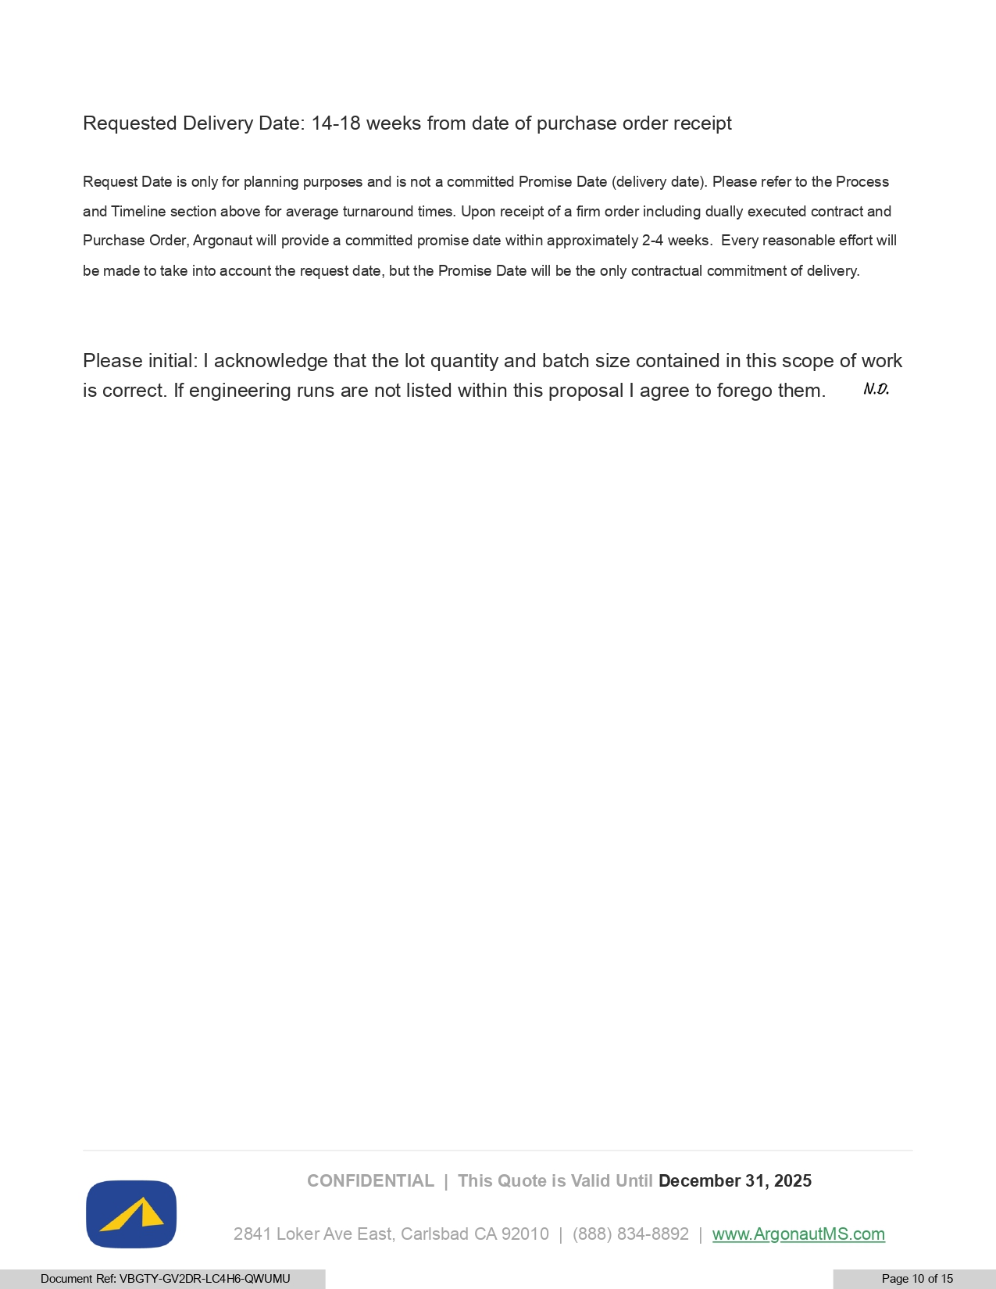
CONFIDENTIAL | This Quote is Valid Until December 31, 2025 Requested Delivery Date: 14 - 18 weeks from date of purchase order receipt Request Date is only for planning purposes and is not a committed Promise Date (delivery date). Please refer to the Process and Timeline section above for average turnaround times. Upon receipt of a firm order including dually executed contract and Purchase Order, Argonaut will provide a committed promise date within approximately 2 - 4 weeks. Every reasonable effort will be made to take into account the request date, but the Promise Date will be the only contractual commitment of delivery. Please initial: I acknowledge that the lot quantity and batch size contained in this scope of work is correct. If engineering runs are not listed within this proposal I agree to forego them. 2841 Loker Ave East, Carlsbad CA 92010 | (888) 834 - 8892 | www.A rg onautMS.com Document Ref: VBGTY - GV2DR - LC4H6 - QWUMU Page 10 of 15

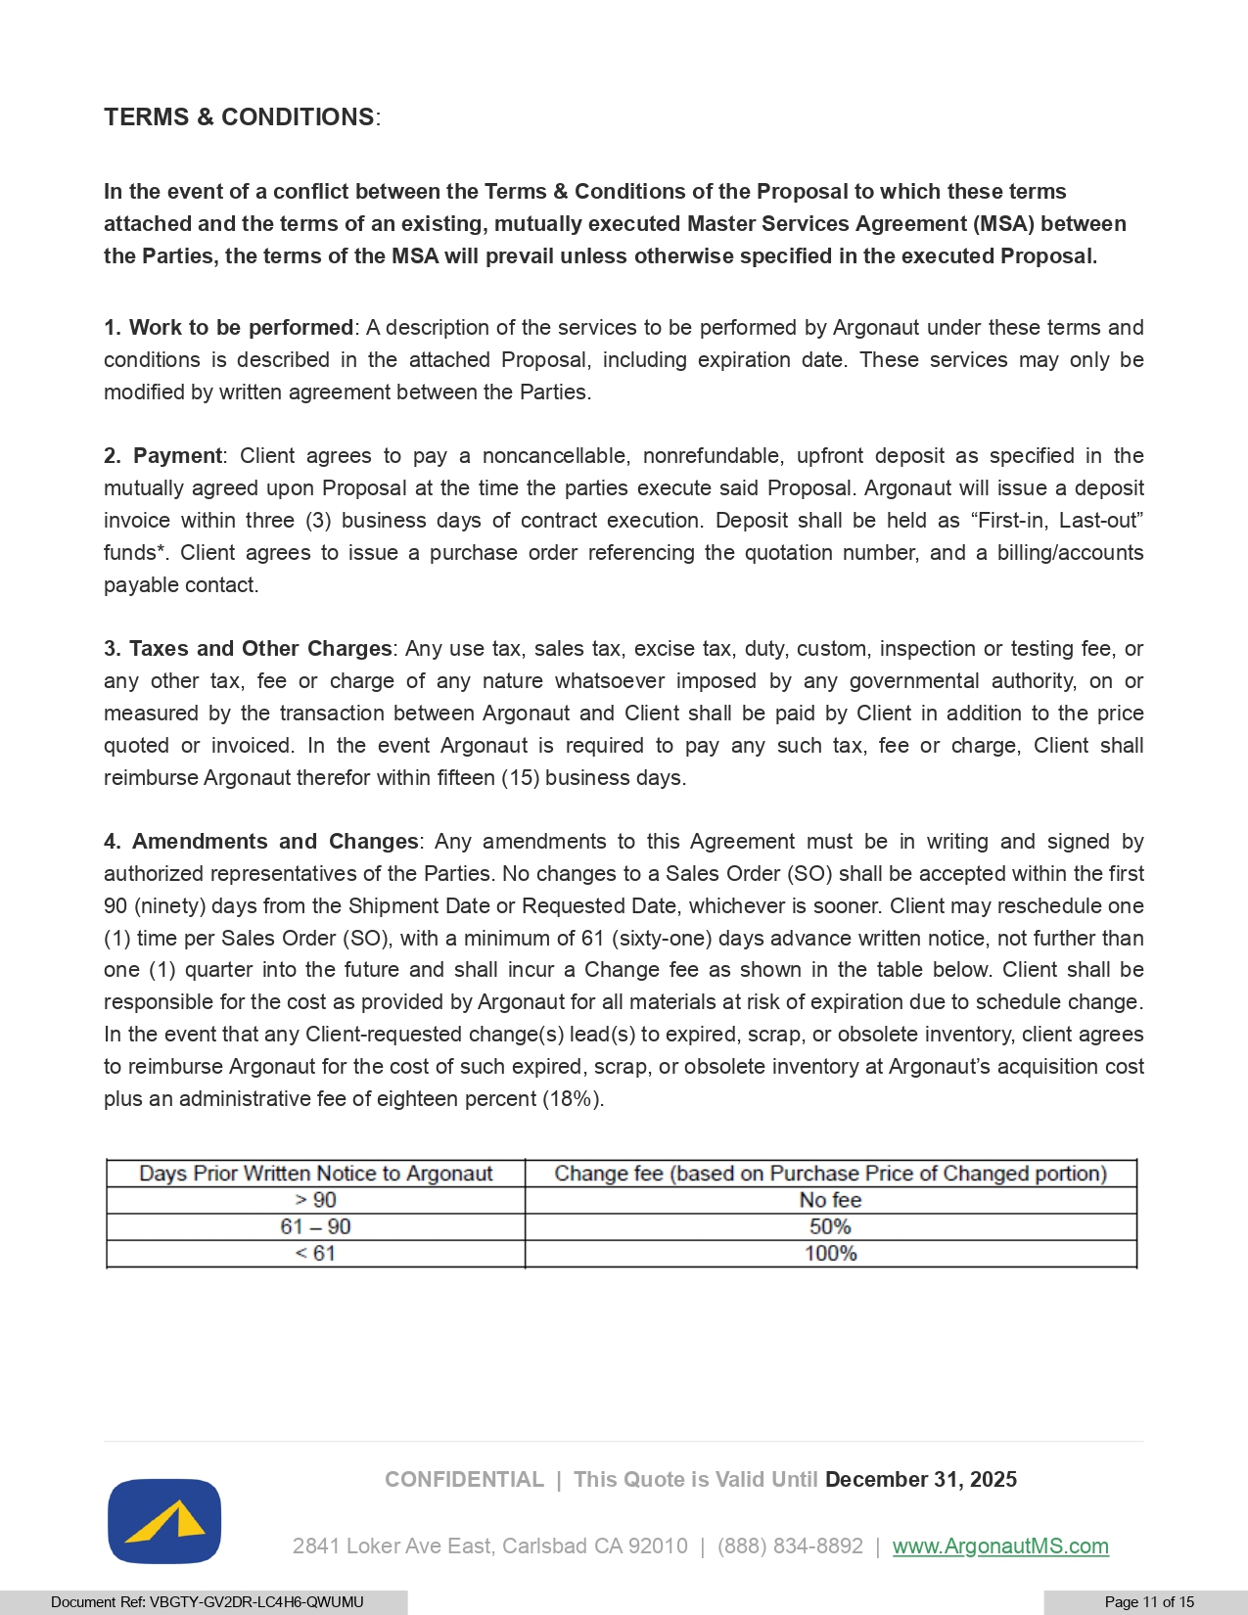
CONFIDENTIAL | This Quote is Valid Until December 31, 2025 TERMS & CONDITIONS : In the event of a conflict between the Terms & Conditions of the Proposal to which these terms attached and the terms of an existing, mutually executed Master Services Agreement (MSA) between the Parties, the terms of the MSA will prevail unless otherwise specified in the executed Proposal . 1. Work to be performed : A description of the services to be performed by Argonaut under these terms and conditions is described in the attached Proposal, including expiration date . These services may only be modified by written agreement between the Parties . 2. Payment : Client agrees to pay a noncancellable, nonrefundable, upfront deposit as specified in the mutually agreed upon Proposal at the time the parties execute said Proposal . Argonaut will issue a deposit invoice within three ( 3 ) business days of contract execution . Deposit shall be held as “First - in, Last - out” funds* . Client agrees to issue a purchase order referencing the quotation number, and a billing/accounts payable contact . 3. Taxes and Other Charges : Any use tax, sales tax, excise tax, duty, custom, inspection or testing fee, or any other tax, fee or charge of any nature whatsoever imposed by any governmental authority, on or measured by the transaction between Argonaut and Client shall be paid by Client in addition to the price quoted or invoiced . In the event Argonaut is required to pay any such tax, fee or charge, Client shall reimburse Argonaut therefor within fifteen ( 15 ) business days . 4. Amendments and Changes : Any amendments to this Agreement must be in writing and signed by authorized representatives of the Parties . No changes to a Sales Order (SO) shall be accepted within the first 90 (ninety) days from the Shipment Date or Requested Date, whichever is sooner . Client may reschedule one ( 1 ) time per Sales Order (SO), with a minimum of 61 (sixty - one) days advance written notice, not further than one ( 1 ) quarter into the future and shall incur a Change fee as shown in the table below . Client shall be responsible for the cost as provided by Argonaut for all materials at risk of expiration due to schedule change . In the event that any Client - requested change(s) lead(s) to expired, scrap, or obsolete inventory, client agrees to reimburse Argonaut for the cost of such expired, scrap, or obsolete inventory at Argonaut’s acquisition cost plus an administrative fee of eighteen percent ( 18 % ) . 2841 Loker Ave East, Carlsbad CA 92010 | (888) 834 - 8892 | www.A rg onautMS.com Document Ref: VBGTY - GV2DR - LC4H6 - QWUMU Page 11 of 15

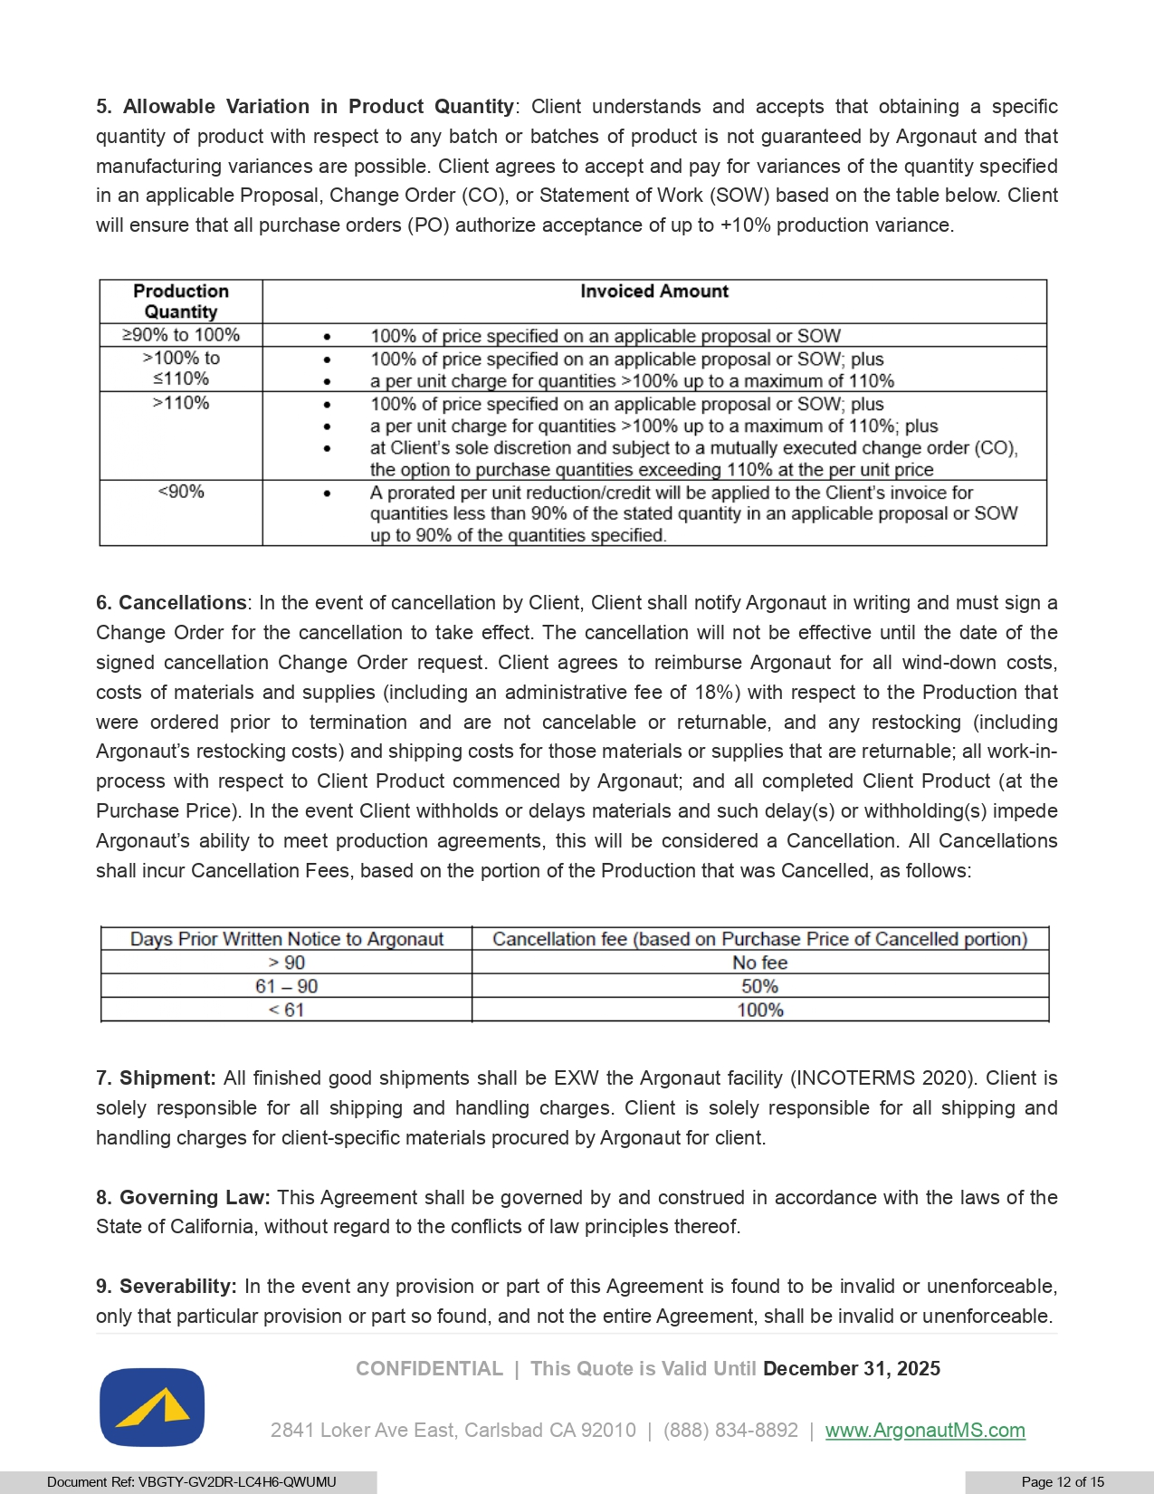
7. Shipment : All finished good shipments shall be EXW the Argonaut facility (INCOTERMS 2020 ) . Client is solely responsible for all shipping and handling charges . Client is solely responsible for all shipping and handling charges for client - specific materials procured by Argonaut for client . 8. Governing Law : This Agreement shall be governed by and construed in accordance with the laws of the State of California, without regard to the conflicts of law principles thereof . 9. Severability : In the event any provision or part of this Agreement is found to be invalid or unenforceable, only that particular provision or part so found, and not the entire Agreement, shall be invalid or unenforceable . CONFIDENTIAL | This Quote is Valid Until December 31, 2025 5 . Allowable Variation in Product Quantity : Client understands and accepts that obtaining a specific quantity of product with respect to any batch or batches of product is not guaranteed by Argonaut and that manufacturing variances are possible . Client agrees to accept and pay for variances of the quantity specified in an applicable Proposal, Change Order (CO), or Statement of Work (SOW) based on the table below . Client will ensure that all purchase orders (PO) authorize acceptance of up to + 10 % production variance . 6 . Cancellations : In the event of cancellation by Client, Client shall notify Argonaut in writing and must sign a Change Order for the cancellation to take effect . The cancellation will not be effective until the date of the signed cancellation Change Order request . Client agrees to reimburse Argonaut for all wind - down costs, costs of materials and supplies (including an administrative fee of 18 % ) with respect to the Production that were ordered prior to termination and are not cancelable or returnable, and any restocking (including Argonaut’s restocking costs) and shipping costs for those materials or supplies that are returnable ; all work - in - process with respect to Client Product commenced by Argonaut ; and all completed Client Product (at the Purchase Price) . In the event Client withholds or delays materials and such delay(s) or withholding(s) impede Argonaut’s ability to meet production agreements, this will be considered a Cancellation . All Cancellations shall incur Cancellation Fees, based on the portion of the Production that was Cancelled, as follows : 2841 Loker Ave East, Carlsbad CA 92010 | (888) 834 - 8892 | www.A rg onautMS.com Document Ref: VBGTY - GV2DR - LC4H6 - QWUMU Page 12 of 15

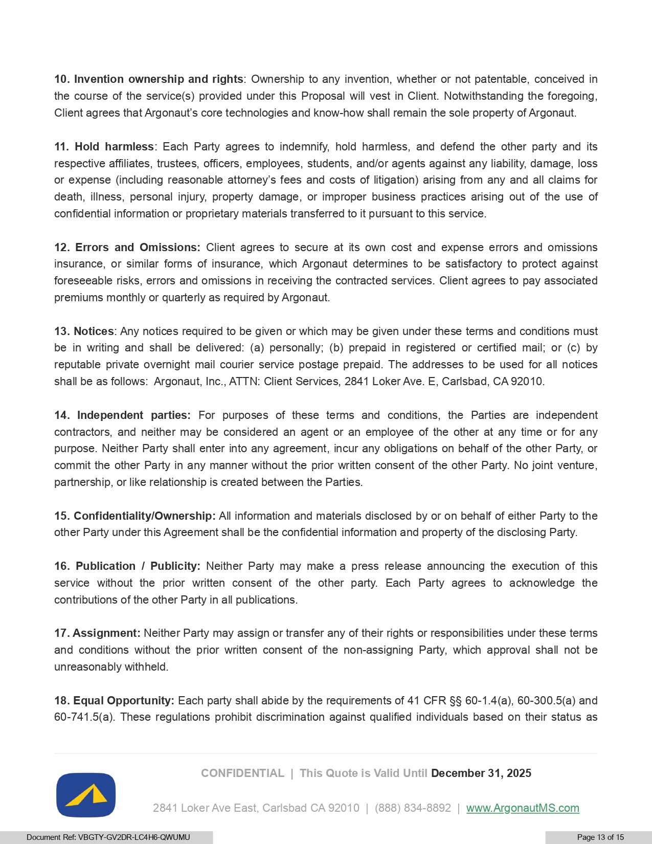
CONFIDENTIAL | This Quote is Valid Until December 31, 2025 10. Invention ownership and rights : Ownership to any invention, whether or not patentable, conceived in the course of the service(s) provided under this Proposal will vest in Client . Notwithstanding the foregoing, Client agrees that Argonaut’s core technologies and know - how shall remain the sole property of Argonaut . 11. Hold harmless : Each Party agrees to indemnify, hold harmless, and defend the other party and its respective affiliates, trustees, officers, employees, students, and/or agents against any liability, damage, loss or expense (including reasonable attorney’s fees and costs of litigation) arising from any and all claims for death, illness, personal injury, property damage, or improper business practices arising out of the use of confidential information or proprietary materials transferred to it pursuant to this service . 12. Errors and Omissions : Client agrees to secure at its own cost and expense errors and omissions insurance, or similar forms of insurance, which Argonaut determines to be satisfactory to protect against foreseeable risks, errors and omissions in receiving the contracted services . Client agrees to pay associated premiums monthly or quarterly as required by Argonaut . 13. Notices : Any notices required to be given or which may be given under these terms and conditions must be in writing and shall be delivered : (a) personally ; (b) prepaid in registered or certified mail ; or (c) by reputable private overnight mail courier service postage prepaid . The addresses to be used for all notices shall be as follows : Argonaut, Inc . , ATTN : Client Services, 2841 Loker Ave . E, Carlsbad, CA 92010 . 14. Independent parties : For purposes of these terms and conditions, the Parties are independent contractors, and neither may be considered an agent or an employee of the other at any time or for any purpose . Neither Party shall enter into any agreement, incur any obligations on behalf of the other Party, or commit the other Party in any manner without the prior written consent of the other Party . No joint venture, partnership, or like relationship is created between the Parties . 15. Confidentiality/Ownership : All information and materials disclosed by or on behalf of either Party to the other Party under this Agreement shall be the confidential information and property of the disclosing Party . 16. Publication / Publicity : Neither Party may make a press release announcing the execution of this service without the prior written consent of the other party . Each Party agrees to acknowledge the contributions of the other Party in all publications . 17. Assignment : Neither Party may assign or transfer any of their rights or responsibilities under these terms and conditions without the prior written consent of the non - assigning Party, which approval shall not be unreasonably withheld . 18. Equal Opportunity : Each party shall abide by the requirements of 41 CFR  60 - 1 . 4 (a), 60 - 300 . 5 (a) and 60 - 741 . 5 (a) . These regulations prohibit discrimination against qualified individuals based on their status as 2841 Loker Ave East, Carlsbad CA 92010 | (888) 834 - 8892 | www.A rg onautMS.com Document Ref: VBGTY - GV2DR - LC4H6 - QWUMU Page 13 of 15

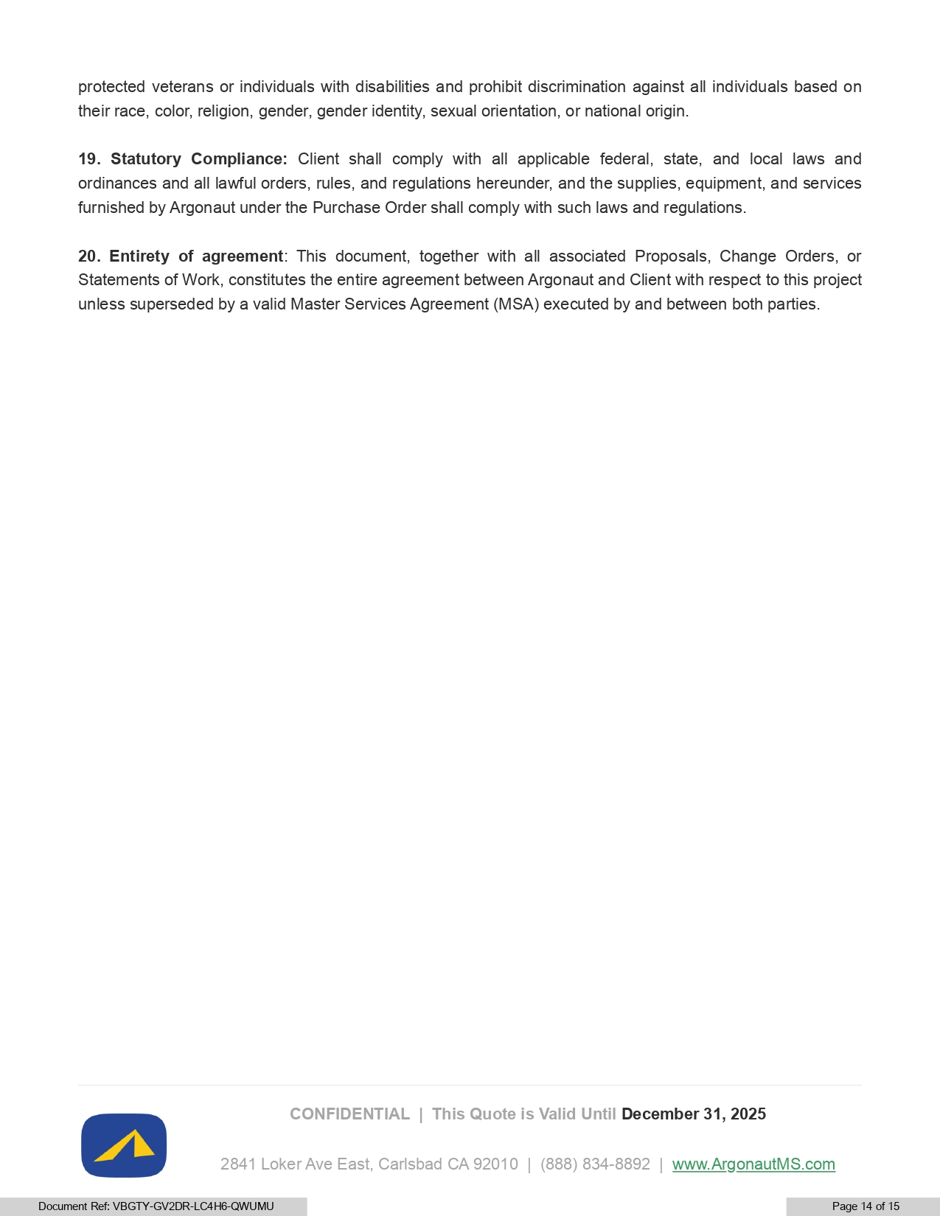
CONFIDENTIAL | This Quote is Valid Until December 31, 2025 protected veterans or individuals with disabilities and prohibit discrimination against all individuals based on their race, color, religion, gender, gender identity, sexual orientation, or national origin. 19. Statutory Compliance : Client shall comply with all applicable federal, state, and local laws and ordinances and all lawful orders, rules, and regulations hereunder, and the supplies, equipment, and services furnished by Argonaut under the Purchase Order shall comply with such laws and regulations . 20. Entirety of agreement : This document, together with all associated Proposals, Change Orders, or Statements of Work, constitutes the entire agreement between Argonaut and Client with respect to this project unless superseded by a valid Master Services Agreement (MSA) executed by and between both parties . 2841 Loker Ave East, Carlsbad CA 92010 | (888) 834 - 8892 | www.A rg onautMS.com Document Ref: VBGTY - GV2DR - LC4H6 - QWUMU Page 14 of 15

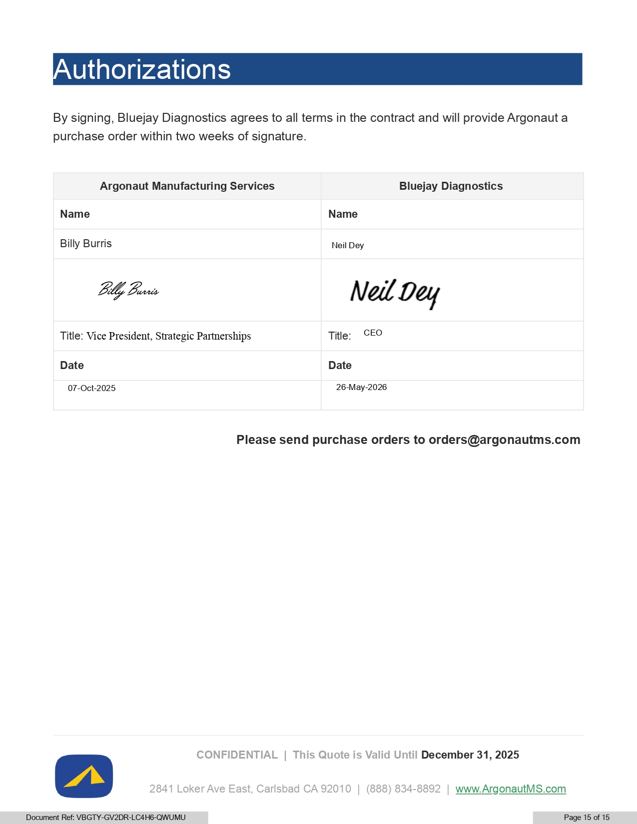
CONFIDENTIAL | This Quote is Valid Until December 31, 2025 Authorizations By signing, Bluejay Diagnostics agrees to all terms in the contract and will provide Argonaut a purchase order within two weeks of signature. Bluejay Diagnostics Argonaut Manufacturing Services Name Name Neil Dey Billy Burris Title: CEO Title: Vice President, Strategic Partnerships Date Date 26 - May - 2026 07 - Oct - 2025 Please send purchase orders to orders@argonautms.com 2841 Loker Ave East, Carlsbad CA 92010 | (888) 834 - 8892 | www.A rg onautMS.com Document Ref: VBGTY - GV2DR - LC4H6 - QWUMU Page 15 of 15

REF. NUMBER VBGTY - GV2DR - LC4H6 - QWUMU DOCUMENT COMPLETED BY ALL PARTIES ON 27 MAY 2026 14:41:19 UTC SIGNER TIMESTAMP SIGNATURE NEIL DEY EMAIL NEIL.DEY@BLUEJAYDX.COM SENT 26 MAY 2026 15:02:50 VIEWED 26 MAY 2026 15:52:14 SIGNED 26 MAY 2026 15:53:40 IP ADDRESS 72.74.32.37 LOCATION ACTON, UNITED STATES RECIPIENT VERIFICATION EMAIL VERIFIED 26 MAY 2026 15:52:14 BILLY BURRIS EMAIL BILLY@ARGONAUTMS.COM SENT 26 MAY 2026 15:02:50 VIEWED 27 MAY 2026 14:41:09 SIGNED 27 MAY 2026 14:41:19 IP ADDRESS 146.75.146.147 LOCATION SAN MARCOS, UNITED STATES RECIPIENT VERIFICATION EMAIL VERIFIED 27 MAY 2026 14:41:09 Signed with PandaDoc PAGE 1 OF 1

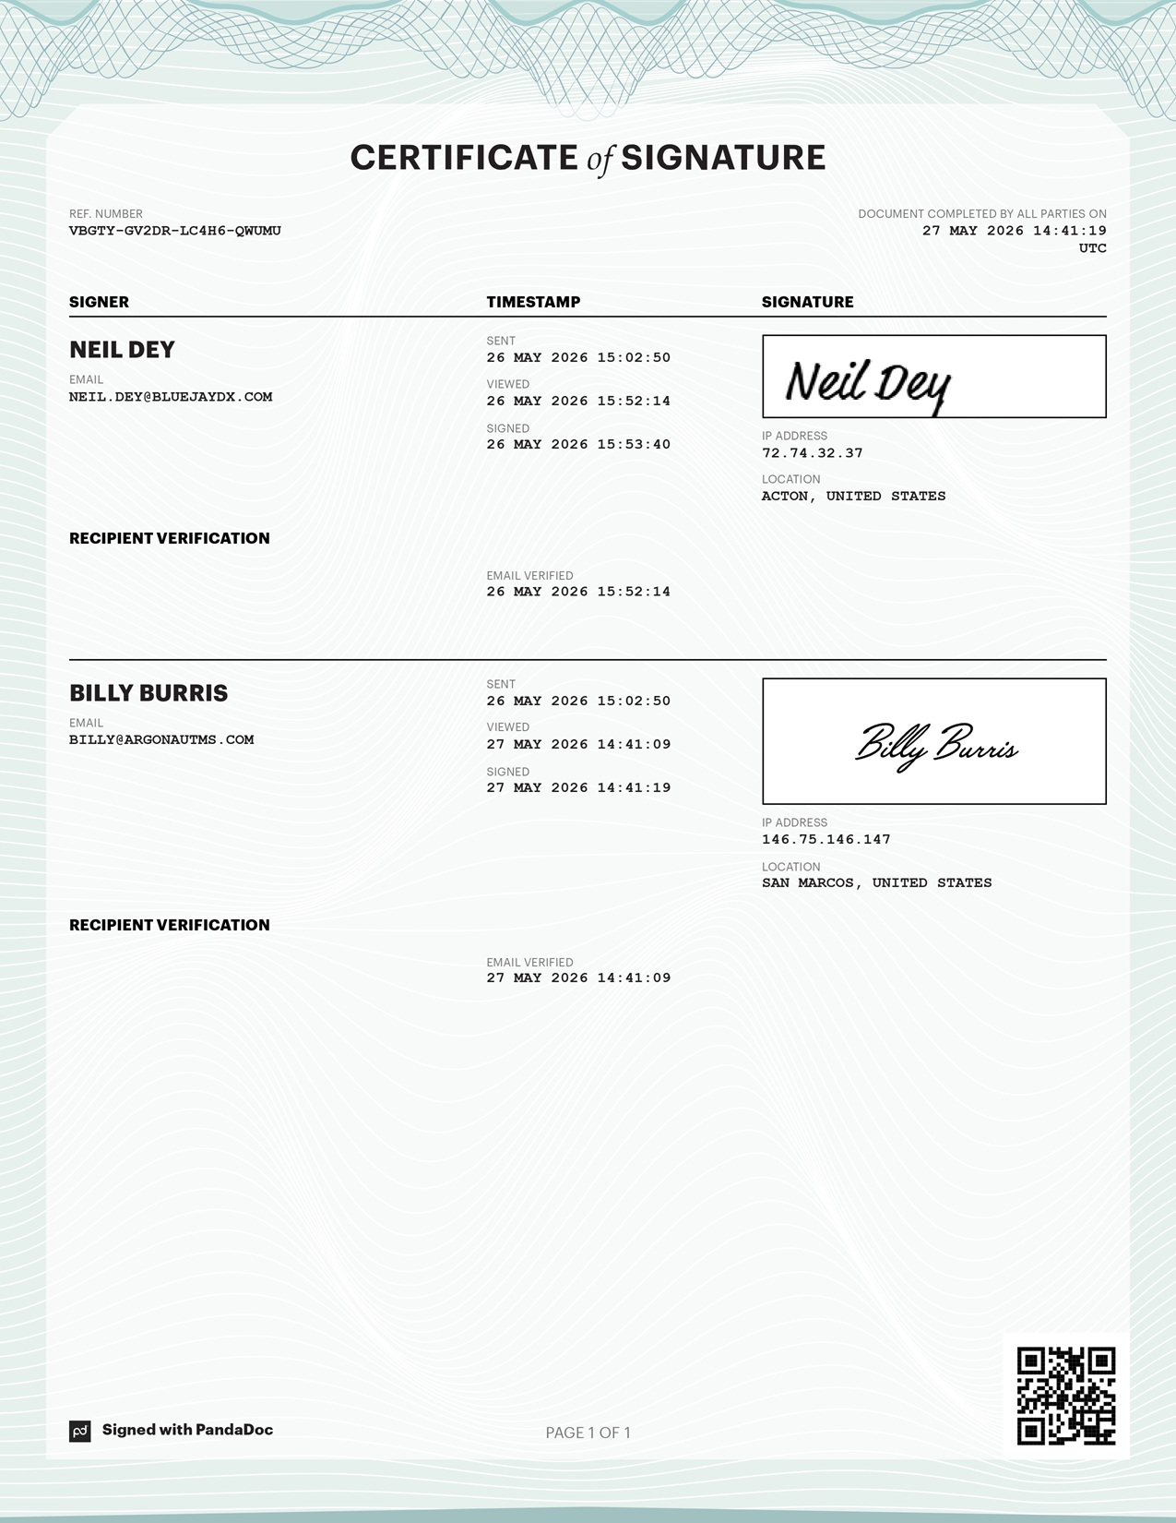
REF. NUMBER VBGTY - GV2DR - LC4H6 - QWUMU DOCUMENT COMPLETED BY ALL PARTIES ON 27 MAY 2026 14:41:19 UTC SIGNER TIMESTAMP SIGNATURE NEIL DEY EMAIL NEIL.DEY@BLUEJAYDX.COM SENT 26 MAY 2026 15:02:50 VIEWED 26 MAY 2026 15:52:14 SIGNED 26 MAY 2026 15:53:40 IP ADDRESS 72.74.32.37 LOCATION ACTON, UNITED STATES RECIPIENT VERIFICATION EMAIL VERIFIED 26 MAY 2026 15:52:14 BILLY BURRIS EMAIL BILLY@ARGONAUTMS.COM SENT 26 MAY 2026 15:02:50 VIEWED 27 MAY 2026 14:41:09 SIGNED 27 MAY 2026 14:41:19 IP ADDRESS 146.75.146.147 LOCATION SAN MARCOS, UNITED STATES RECIPIENT VERIFICATION EMAIL VERIFIED 27 MAY 2026 14:41:09 Signed with PandaDoc PAGE 1 OF 1

ul

Exhibit 99.1



Bluejay Diagnostics and Argonaut Manufacturing Services Announce Strategic Partnership

ACTON, MA/CARLSBAD, CA., June 2, 2026 — Bluejay Diagnostics, Inc. (“Bluejay” or the “Company”) (NASDAQ: BJDX), a medical diagnostics company focused on near-patient testing for critical care, today announced a strategic partnership with Argonaut Manufacturing Services (“Argonaut”) to support the advancement of Bluejay’s Symphony™ platform.

This partnership is designed to support Bluejay’s broader efforts to establish scalable U.S.-based manufacturing capabilities aligned with its ongoing clinical development programs and future commercialization objectives. In addition, the partnership is intended to strengthen Bluejay’s future commercial infrastructure by supporting broader product distribution across the United States, enhancing supply chain resilience, and reducing potential risks associated with international sourcing and import tariffs. The collaboration is also intended to mitigate risks associated with Bluejay’s current reliance on overseas manufacturing by establishing domestic manufacturing capabilities that can provide greater operational control, business continuity, and supply chain security. By leveraging U.S.-based manufacturing and distribution capabilities, Bluejay aims to improve operational flexibility, support future market demand, and further enhance its ability to commercialize innovative near-patient diagnostic solutions for critical care settings.

“We are pleased to partner with Argonaut as we continue to advance the Symphony™ platform,” said Neil Dey, President and Chief Executive Officer of Bluejay Diagnostics. “This collaboration reflects our commitment to building a scalable and quality-focused operational foundation as we progress toward key commercial milestones.”

“Argonaut is committed to partnering with innovative companies to support the advancement of differentiated diagnostic technologies,” said Rick Hancock, Chief Executive Officer of Argonaut Manufacturing Services. “We value this collaboration with Bluejay Diagnostics and look forward to supporting their efforts as they continue to develop solutions aimed at improving clinical decision-making in critical care settings.”

Note: Investigational device. Limited by United States law to investigational use.

About the SYMON Clinical Study Program:

The SYMON Clinical Study Program includes SYMON-I (clinicaltrials.gov ID NCT06181604), SYMON-II (NCT06654895), and SYMON-III (NCT07425587). SYMON-I is a pilot study to determine IL-6 levels associated with various endpoints, including, but not limited to 28-day all-cause mortality and in-hospital mortality. The SYMON-II study is the pivotal study to validate the outcomes of the SYMON-I study, which the Company plans to use to support a 510(k) application to the FDA. The SYMON-III study is a pilot study to determine IL-6 levels associated with patients presenting with increasing severity of infection in the emergency department and risk of developing sepsis.

About Bluejay Diagnostics:

Bluejay Diagnostics, Inc. is a medical diagnostics company focused on improving patient outcomes using its Symphony System, a cost-effective, rapid, near-patient testing system for sepsis triage and monitoring of disease progression. Bluejay does not yet have regulatory clearance for the Symphony System, and we will need to receive regulatory authorization from the U.S. Food and Drug Administration before Symphony can be marketed as a diagnostic product in the United States. Bluejay’s first product candidate, an IL-6 Test for sepsis, is designed to provide accurate, reliable results in approximately 20 minutes from ’sample-to-result’ to help medical professionals make earlier and better triage/treatment decisions. More information is available at www.bluejaydx.com.

About Argonaut Manufacturing Services:

Argonaut Manufacturing Services is a contract manufacturing organization focused on supporting life sciences and diagnostics companies with high-quality manufacturing solutions. Founded by former executives from companies such as Thermo Fisher Scientific, Affymetrix, and Allergan, Argonaut was built to provide a better, customer-focused approach to contract manufacturing.

The company’s mission is centered on improving the human condition by helping partners bring innovative healthcare products to market efficiently and reliably. Drawing from decades of industry experience, Argonaut emphasizes quality, operational excellence, and strong customer collaboration to help clients achieve their commercial and development goals in the health and life sciences industries.

Forward-Looking Statements:

This press release contains statements that the Company believes are “forward-looking statements” within the meaning of the Private Litigation Reform Act. Forward-looking statements may be identified by words such as “anticipates,” “believes,” “estimates,” “expects,” “intends,” “may,” “plans,” “projects,” “seeks,” “should,” “suggest,” “will,” and similar expressions. The Company has based these forward-looking statements on its current expectations and projections about future events, nevertheless, actual results or events could differ materially from the plans, intentions and expectations disclosed in, or implied by, the forward-looking statements the Company makes. These statements are only predictions and involve known and unknown risks, uncertainties, and other factors, including market and other conditions and those discussed under item 1A. “Risk Factors” in the Company’s Annual Report on Form 10-K for the fiscal year ended December 31, 2025, and in Part II, Item 1A, “Risk Factors” in its Quarterly Report on Form 10-Q for the fiscal quarter ended March 31, 2026. You should not place undue reliance on these forward-looking statements, as they are subject to risks and uncertainties, and actual results and performance in future periods may not occur or may be materially different from any future results or performance suggested by the forward-looking statements in this release. This press release speaks as of the date indicated above. The Company undertakes no obligation to update any forward-looking statements, whether as a result of new information, future events, or otherwise, except as required by law. The Company expressly disclaims any obligation to update or revise any forward-looking statements found herein to reflect any future changes in the Company’s expectations of results or any future change in events, except as required by law.

Investor Contact:

Neil Dey
Bluejay Diagnostics, Inc.
neil.dey@bluejaydx.com

Website: www.bluejaydx.com

